
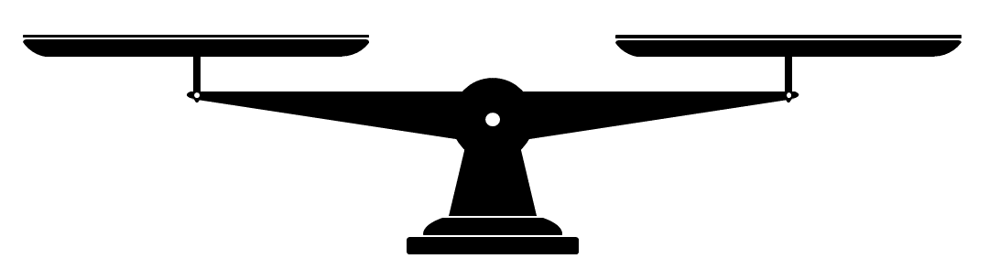
________________________________________________________________________________________________________________
________________________________________________________________________________________________________________
Unsere Klassenregeln

